# Project Name: News Application

## Group info:

|  |  |  |
| --- | --- | --- |
| **Group Member names** | **Old Roll no** | **Class** |
| Gunveen Kaur Bindra | 3001 | SYIT |
| Sachi Shah | 3066 | SYIT |
| Nidhee Panchal | 3076 | SYIT |
| Dikshita Shetty | 3077 | SYIT |

## Project Description:

Our project is a news application which will fetch the information from different sources and will display all of them on a single application. Getting the latest live news articles from a range of [sources](https://newsapi.org/sources), including BBC News, CNN, TechCrunch, Huffington Post and more, along with different categories, like technology, sports, business, science and entertainment.

We have chosen **Angular** for our project, since Angular is a platform that makes it easy to build applications with the web. Angular combines declarative templates, dependency injection, end-to-end tooling, and integrated best practices to solve development challenges.

In our application, we have used an API which will render us some headlines, images, etc. from different sources as JSON data. We have implemented this in the application template. The News API is a simple HTTP REST API for searching and retrieving live articles from all over the sources available on the web.

## PHASE 1: Screen Design

Screen design and UI of the application

### Sign In / Sign Up page

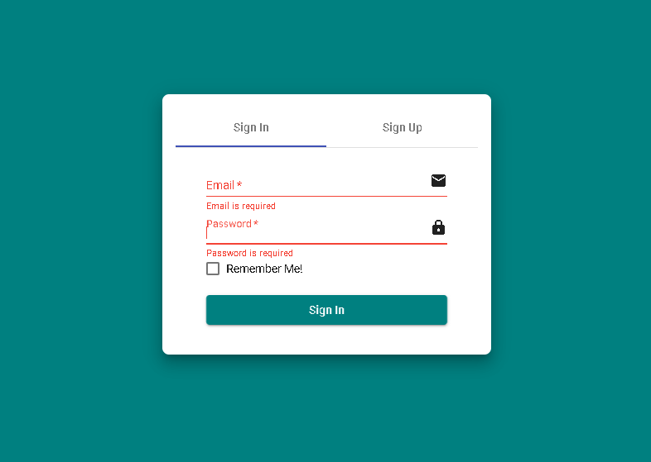

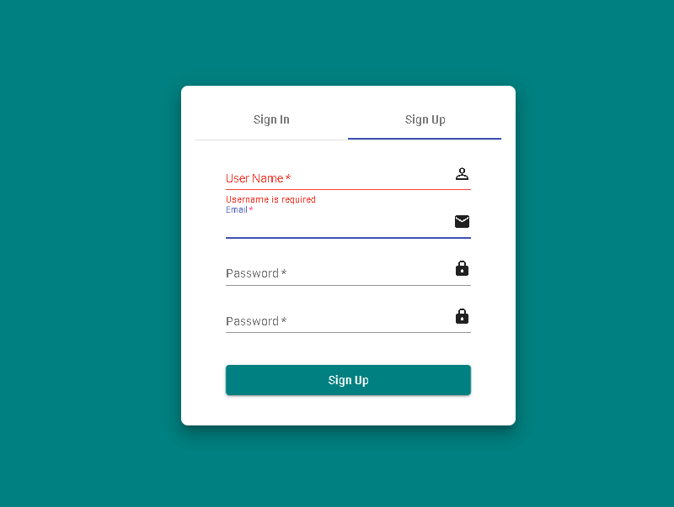

### Home Page

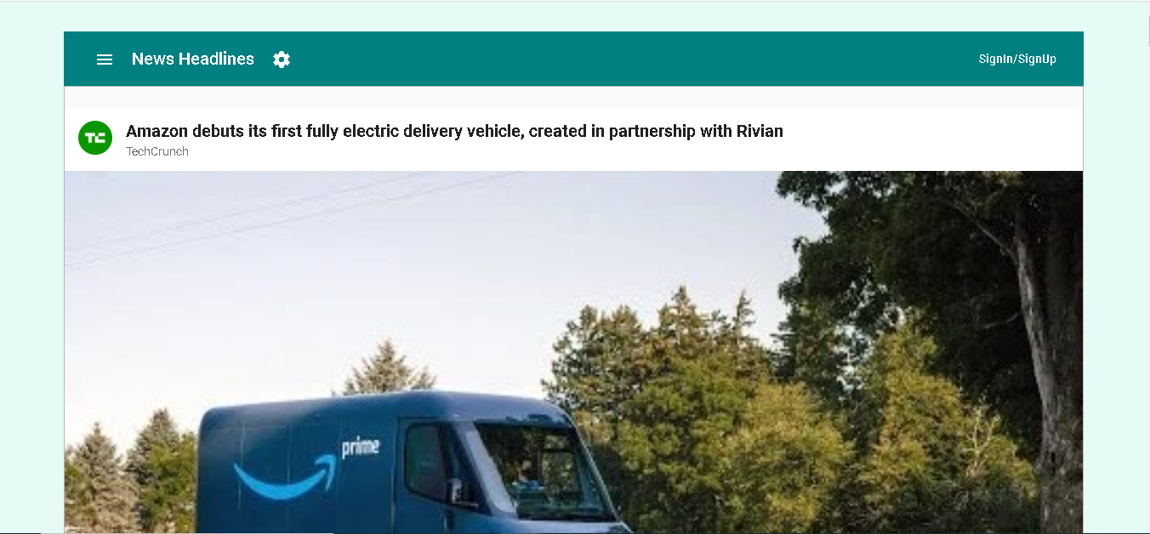

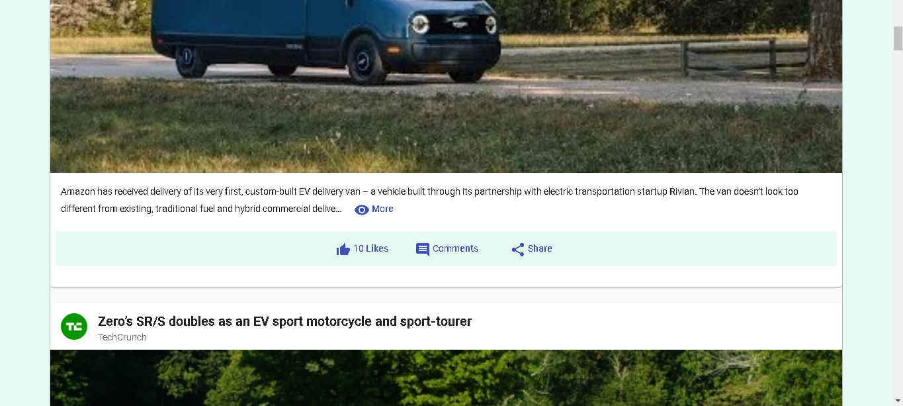

**Changing the sources using the hamburger icon**

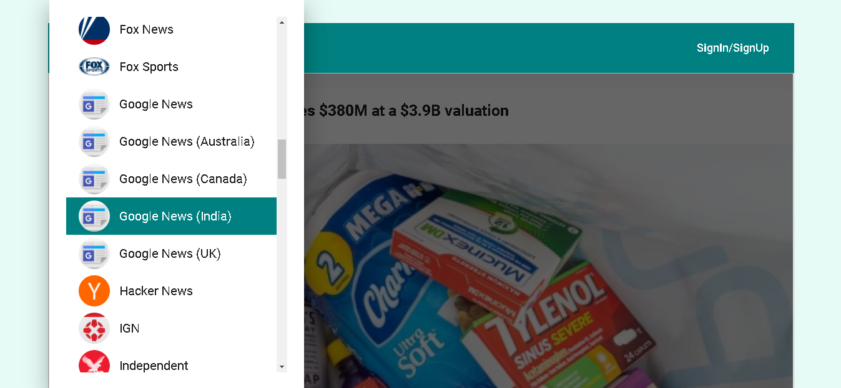

### Features

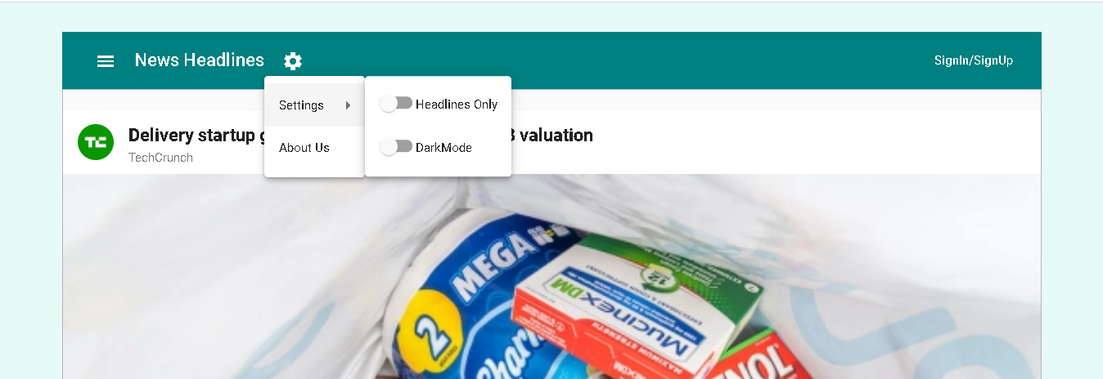

**HeadLines only**

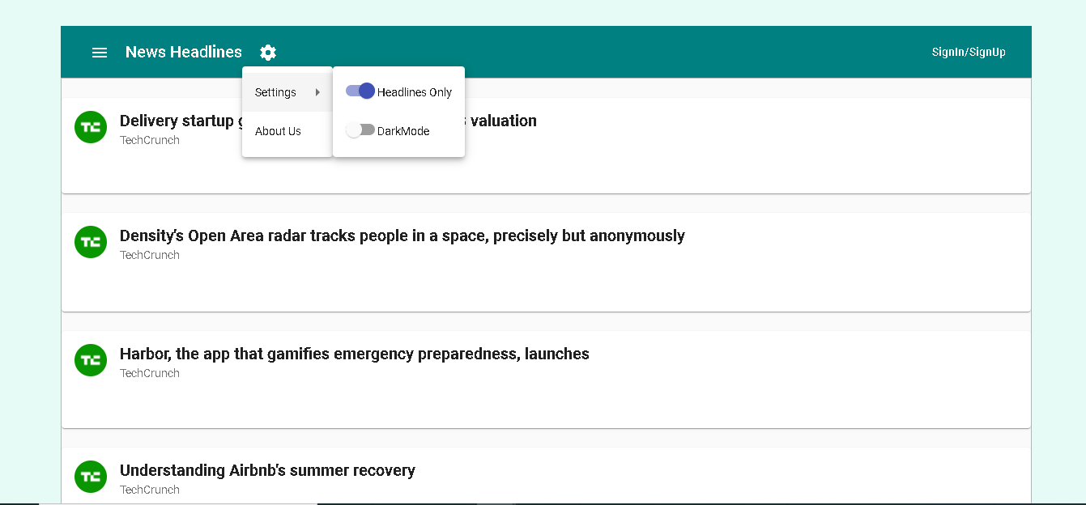

**Dark Mode :** 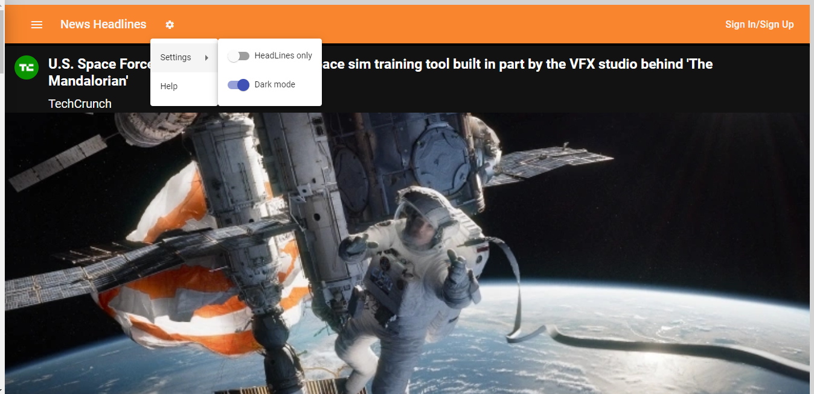

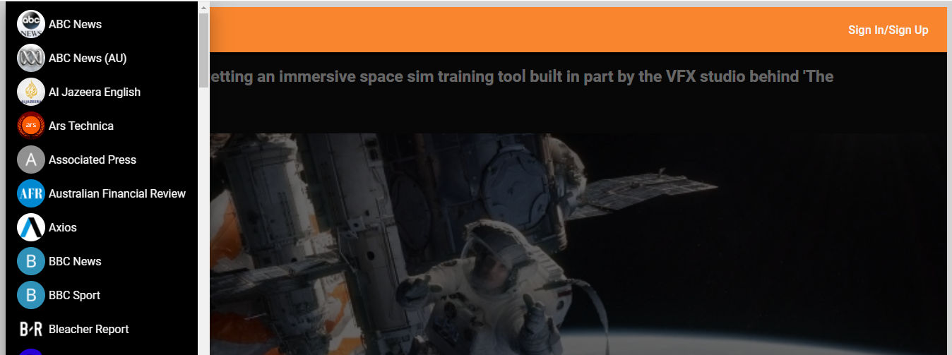

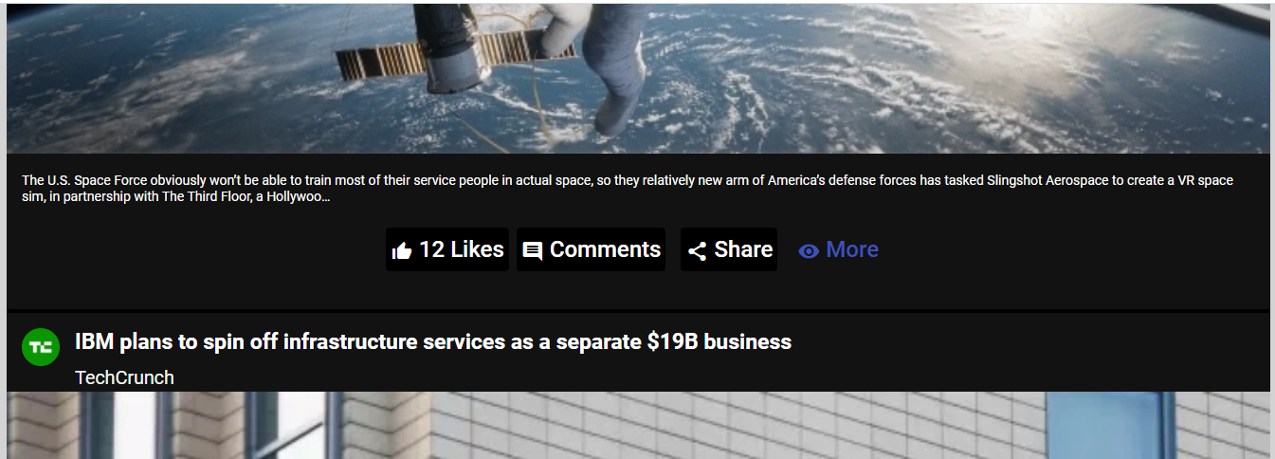

**About us page:**

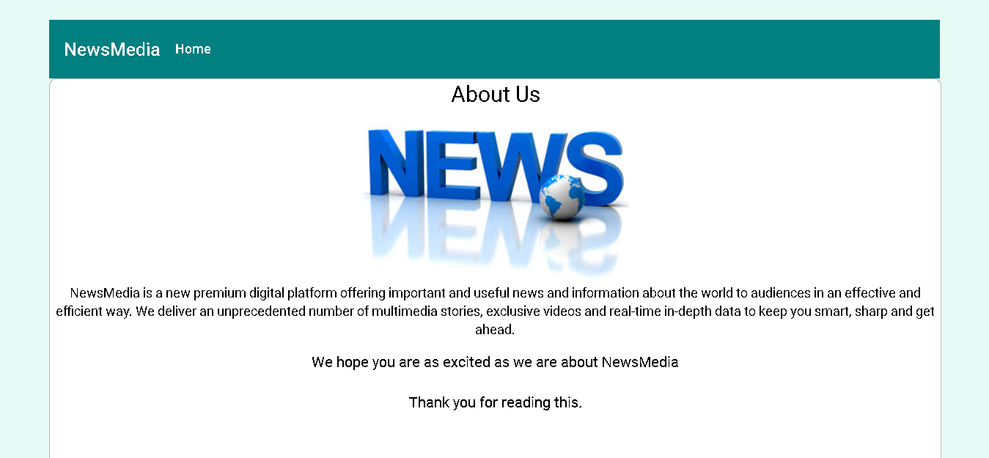

### Button events

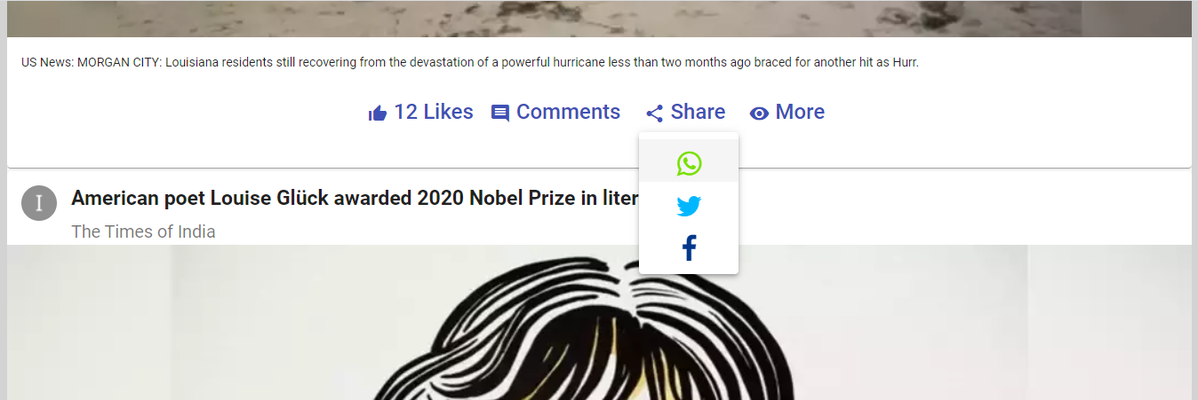

## PHASE 2: Stack

We will be using **Mean - Stack** for authenticating users

Mean Stack Architecture consists of MongoDB, Express JS, Angular JS, and NodeJS.

**Framework used:** Angular with material design